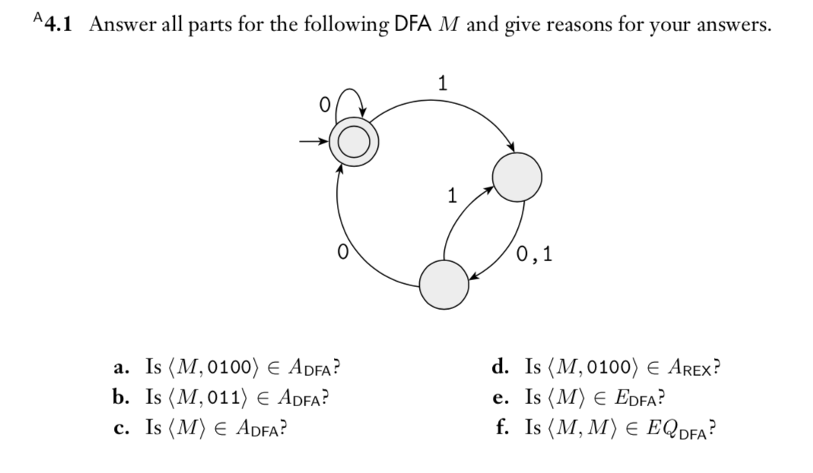

A.
Does M accept input string 0100?
0 -> accept state
Yes, the first 0 will lead to an acceptable state.

B.
Does M accept input string 011?
0 -> accept state
Yes, the first 0 will lead to an acceptable state.

C.
Does M accept “empty”?
From the DFA there is not state for “empty” so.
M does not accept the input string.

D.
<M, 0100> M is a DFA, not a regular expression.
M doesn’t generate 0100.

E.
Looking at the eDFA we can see that
M cannot accept any string.

F.
Do 2 DFA equal the same language?
We are asking if M accepts the same language as M
Yes, M and M are the same, and thus accept the same language.

